# Preview of Movies App

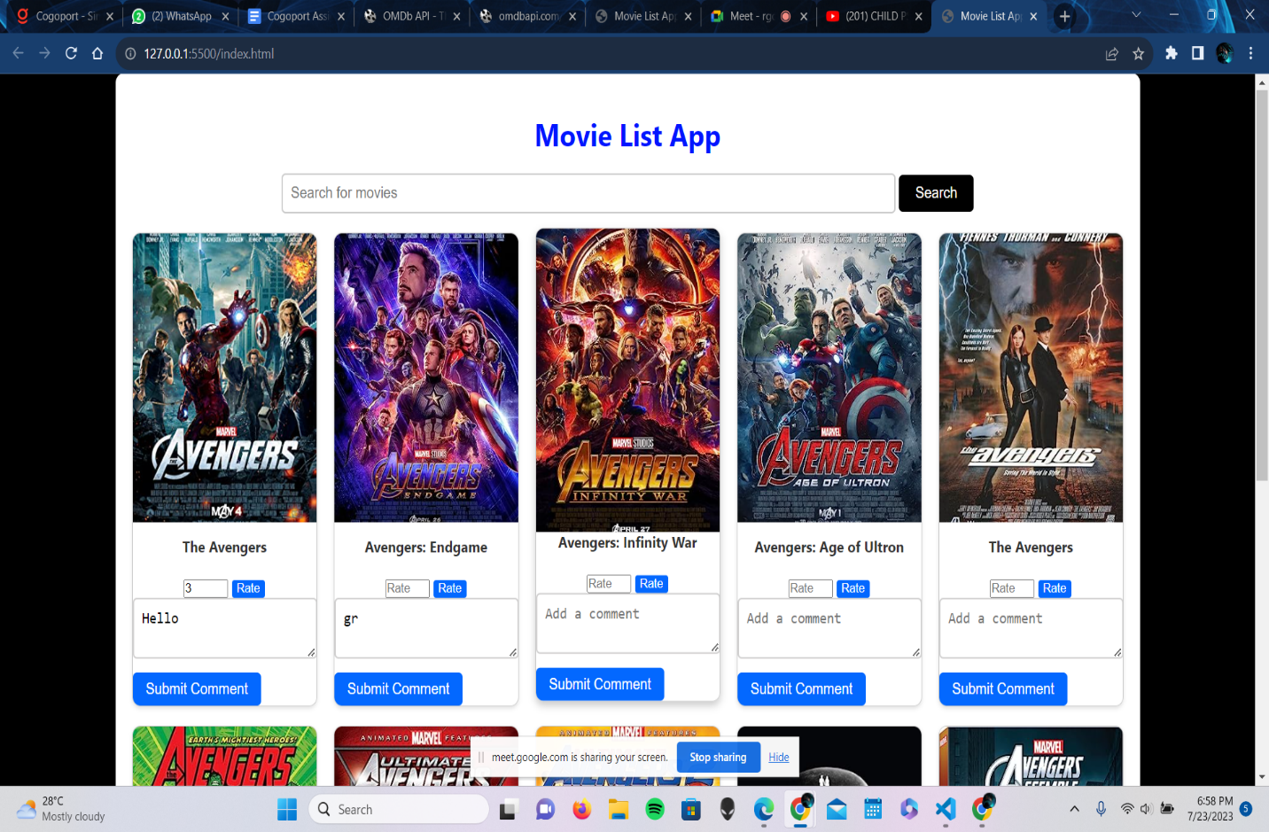

Movie Detais -

